A. Introduction

A.1. Description & Disscusion of the Background

I am currently living in Madrid, so I know it very well and I chose to use it to my project. Madrid is the capital of Spain and the largest city in the country. It has a population over 6.5 million people in all his region, an about 3.5 million of people in the city, according INE 2019, with a high density of population 5321,05 people/km². Regarding the update data, it is the 5th most populated y in Europe[1].

Place in the center of the Iberian Peninsule, over 646m above sea level. Madrid, is divides into 21 boroughs with 131 neighbourhoods around 604,3 km², preserving one of the most important historical centers among the great European cities, which is harmoniously merged with the most modern and how infrastructures, a complete offer of accommodation and services and the most advanced technology in audiovisual and communication media. Conditions that, together with the drive of a dynamic and open society, but also joyful and welcoming, have made this metropolis one of the great capitals of the western world.

The Madrid population has a preferably young-adult age profile: 44.4% of the region's inhabitants are between 16 and 44 years old (INE 2006). The city has 230.018 M€ of GDP, and a nominal GDP per capita of 34.916€, being the 1st economical metropolis of Spain and the 10th of Europe, behind London, Paris, Rin-Ruhr, Amsterdam, Milan, Brussels, Moscu, Francfort del Meno and Munich.

Due to the economic potential city of Europe, when we think of it by the investor, we expect from them to prefer the districts where there is a high average income cost and the type of business they want to install is less intense. If we think of the city residents, they may want to know which type of social places they have around a neighbourhood to spend money on. However, it is difficult to obtain information that will guide investors in this direction, nowadays.

When we consider all these problems, we can create a map and information chart where the average income per is placed on Madrid and each district is clustered according to the venue density.

A.2. Data Description

To consider the problem we can list the datas as below:

* I found the Average Income per capita by postal code and neighbourhood of Madrid city [2] The .json file has the name of the neighbourhood and the postal code with the average income I used it to create choropleth map of Average Income per Capita.
* I used Forsquare API to get the most common venues of given Neighbourhood of Madrid [3].

- There are many public datas related to demographic and social parameters for the city of Madrid. In this case, I collected the geographical area point for each Neighbourhoods [4][5].

B. Methodology

As a database, I used GitHub repository in my study. My master data which has the main components Borough, Average Income per capita, Latitude and Longitude information’s of the city.

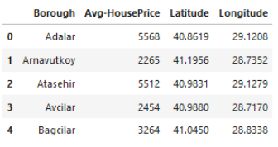

I used python folium library to visualize geographic details of Istanbul and its boroughs and I created a map of Istanbul with boroughs superimposed on top. I used latitude and longitude values to get the visual as below:

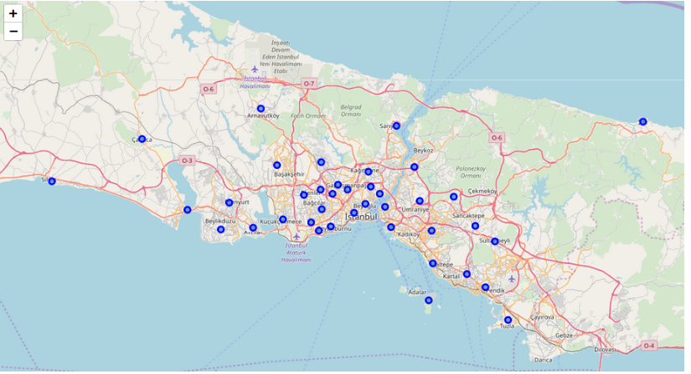

I utilized the Foursquare API to explore the boroughs and segment them. I designed the limit as **100 venue** and the radius **750 meter** for each borough from their given latitude and longitude informations. Here is a head of the list Venues name, category, latitude and longitude informations from Forsquare API.

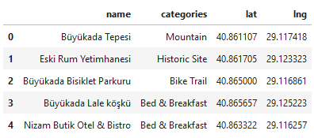

In summary of this data **43** venues were returned by Foursquare. Here is a merged table of boroughs and venues.

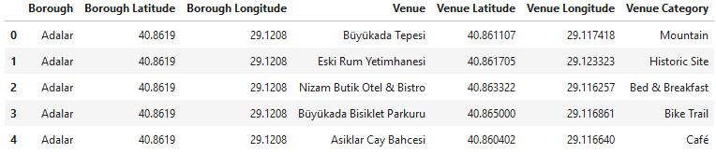

We can see that Kadikoy, Maltepe, Beyoglu, Besiktas, Sisli and Fatih how reached the **100** limit of venues. On the other hand; Pendik, Arnavutkoy, Tuzla, Adalar, Buyukcekmece, Sultangazi, Cekmekoy, Beylikduzu, Sultangazi boroughs are below **20** venues in our given coordinates with Latitude and Longitude, in below graph.

The result doesn’t mean that inquiry run all the possible results in boroughs. Actually, it depends on given Latitude and Longitude informations and here is we just run single Latitude and Longitude pair for each borough. We can increase the possibilities with Neighborhood informations with more Latitude and Longitude informations.

References:

* [1] [Madrid — Wikipedia](https://en.wikipedia.org/wiki/Madrid)
* [2] [Average Income of Madrid Neighbourhood -- Epdata](https://www.epdata.es/datos/datos-graficos-estadisticas-municipio/52/madrid/4245)
* [3] [Forsquare API](https://developer.foursquare.com/" \t "_blank)
* [4] <http://centrodedescargas.cnig.es/CentroDescargas/index.jsp>
* [5][Geographical information of Neighbourhoods of Madrid](https://datos.madrid.es/portal/site/egob/menuitem.c05c1f754a33a9fbe4b2e4b284f1a5a0/?page=0&vgnextoid=b3c41f3cf6a6c410VgnVCM2000000c205a0aRCRD&vgnextchannel=374512b9ace9f310VgnVCM100000171f5a0aRCRD&vgnextfmt=default)